Press Release

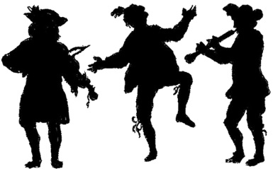
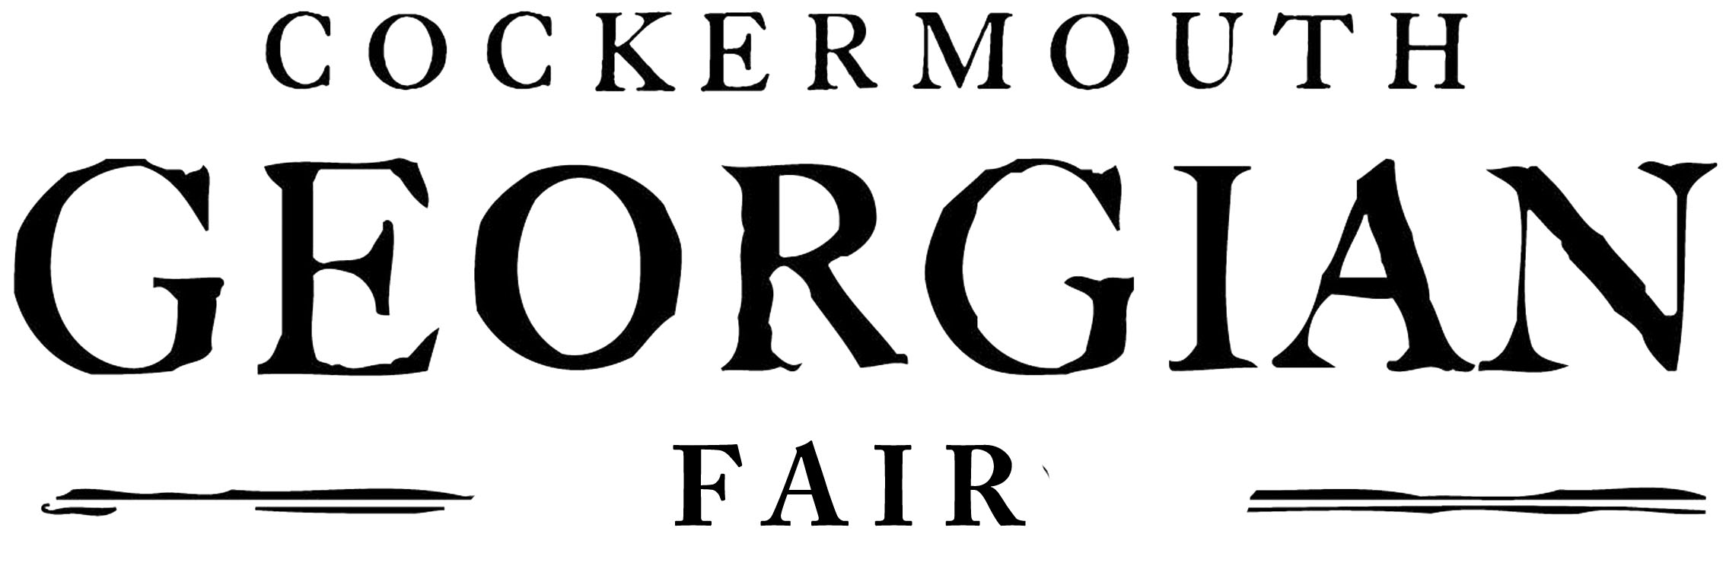
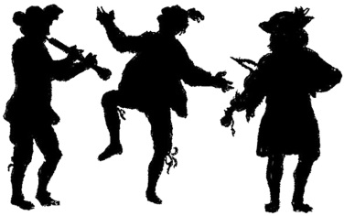

Patrons: Lord & Lady Judd

13 December 2013
For immediate release.

Important Announcement

The Cockermouth Georgian Fair Organising Group has had to make the difficult decision to postpone next year’s Georgian Fair until 2015.

Next spring there will be major work to repair drains and to carry out improvements to the road and footways in Main Street. This work combined with the legal complications of road closures present insurmountable difficulties which prevent us from staging part the event on Main Street as usual.

Cumbria County Council Traffic Management Team have suggested alternative locations for the Fair but none of these provide the best opportunities for local and visiting traders, nor do they allow townsfolk and visitors to appreciate the superb work done by many businesses in improving their shop fronts.

To restrict the Georgian Fair to Market Place and the Bitterbeck Car Park would limit the event to one end of the town and would reduce the amount of performance and dancing spaces.

The Organising Group believe it is important to put on a top rate event and we feel that to change location or to reduce the scale of the event would be to compromise the quality and scope of the Fair.

We have decided to postpone the event for one year to SATURDAY 2nd MAY 2015 when we will put on a Georgian Fair of which Cockermouth will be proud.

We are very grateful to all our friends and supporters for their good wishes and hope that everyone will understand that, having explored all the alternatives we have had to make this difficult decision. We hope the town’s businesses, community groups and residents will appreciate that we only want the best for our remarkable town.

There will be some Georgian related events in 2014 – look out for information from The Kirkgate and other publicity.

NOTES TO EDITORS

ABOUT COCKERMOUTH GEORGIAN FAIR
The first Cockermouth Georgian Fair was held in 2005 and there have been subsequent Georgian Fairs in 2006, 2008, 2010 and 2012. The next Cockermouth Georgian Fair will be held on 2nd May 2015.

Stuart Wiltshire
Georgian Fair Marketing & Publicity Co-ordinator
01900 827809

